**Basic Settings for the website from the Admin Panel:**

For basic website setup such as logo, favicon, site title and meta descriptions/keywords, go to SEO menu in your admin panel.

To change the title on the emails being sent out -> you need to change the Site name option.

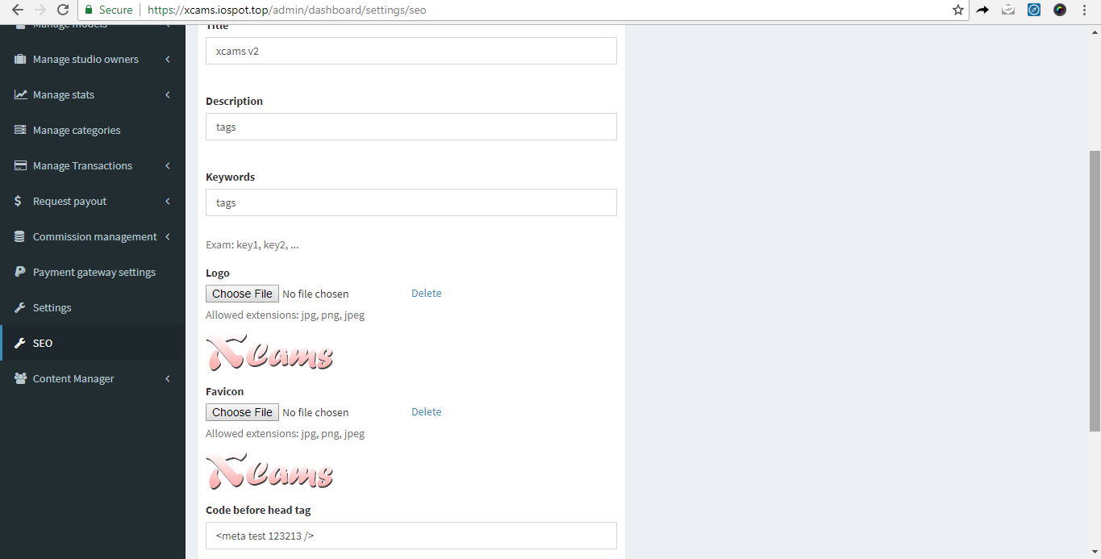

Settings :

Under the settings menu, this is where you will update the systems primary settings such as commission, tokens and banners.

1. Default Model %:

Set the default model commission % from this menu.

B) Default Studio %

Set the default studio commission % from this menu.

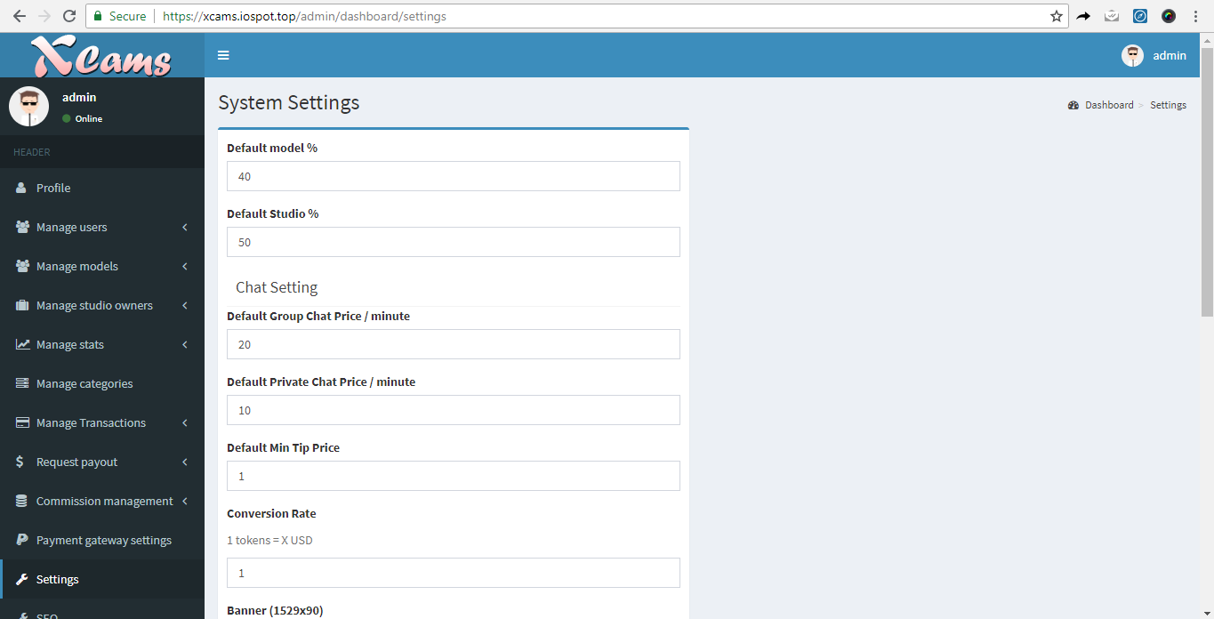

**Commission % explained:**

Total - 100%   
There are 3 players. Admin, Individual Models, Studio ( models contracted under the studio - let’s call them studio models )

Total - 100% - This 100% need to be split between Two groups.

1. Admin → Individual Models.
2. Admin → Studio owner → Studio Models.

Let’s talk about the commission between Admin and Individual models

Total - 100%

Admin - keeps 30%

Individual model - keeps 70%.

This is pretty straightforward.

.

.

Second group - Admin → Studio owner → Studio Models.

Total - 100%.

Admin - keeps 30%

Studio - Keeps 70%.

Out of this 70% - Studio can assign commission % to their studio models.

A studio who owns 70% , can assign only less than equal to 70% to any model under their studio.   
  
Eg : Studio Universe - has 5 models under them. Models are Jane, Jessie, Mary, Annie, Kary.

Studio Universe - 70% ( assigned by the admin )

Studio assigns Jane - 55% ( which means - Jane owns 55% and Studio takes 15% and admin takes 30% = Total 100% )

Studio assigns Jessie ( she is a top performing model ) - 69% - which means studio takes 1%. Admin takes 30%.

If Jessia makes $5000 per month - then Jessie gets $3450, Studio gets $50 and Admin takes $1500.

C) Chat Setting :

On the website, we have 3 different live stream options.

-> Public chat which is the free chat.

-> Private chat where users can invite models for a private one-on-one video chat. The default price for a user to enter private on the website chat can be set here.

-> Group chat where users can invite a model who is already in a private chat with another user. If the model accepts, it will be come a group chat. Multiple users can join the group chat. Or a model can also directly start a group chat from their streaming page. The default price for a user to enter group chat on the website can be set here.

You can set the default chat price from this option.

D) Conversion Rate :

The admin can set the token conversion rate with this option. Ex: conversion rate = 0.1

=> 1 token = $0.1

So the tokens that a model receives from users will be converted into $$ as per the conversion rate which will be shown as total in the models earnings. With this amount, the model can claim her payout from the admin.

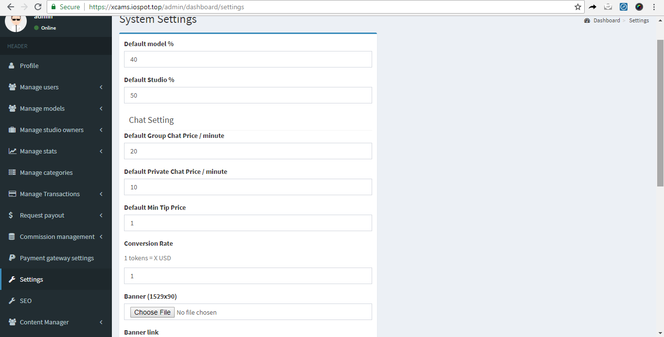

Banners and other images that are available on the shown on the website can be changed using the further options.

**Admin Panel Core menu:**

The xCams admin panel/dashboard is where you can completely manage the frontend of the website using various listed menu options .

1. Manage Users

Under manage users menu, you can view/add/edit/delete any user profile on the website. It has the following options.

1. List users

Here, the complete list of users who have signed up on the website is shown. It also shows some key points such as no. of tokens a user has , no. of tokens a user has spent and total time spent by a user watching live streams on the website under the respective columns.

An existing user profile can be edited/deleted/disabled/enabled/suspended using the option marked in below screenshot. All details of a users profile can be edited by selecting that option and updated on to the website.

**When a new user signs up on the website, the account should be verified by admin here and only then the user can access his account on the frontend.**

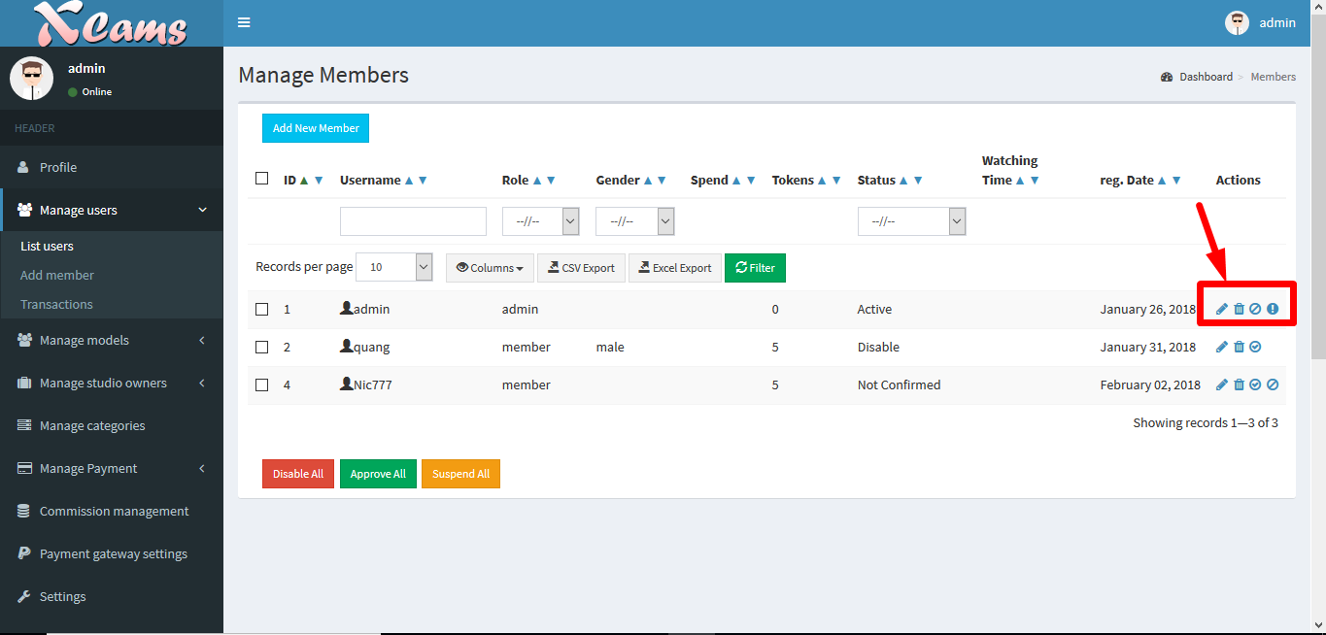

B) Add member -

A new user/member can be directly created from the backend by the website admin using this option.

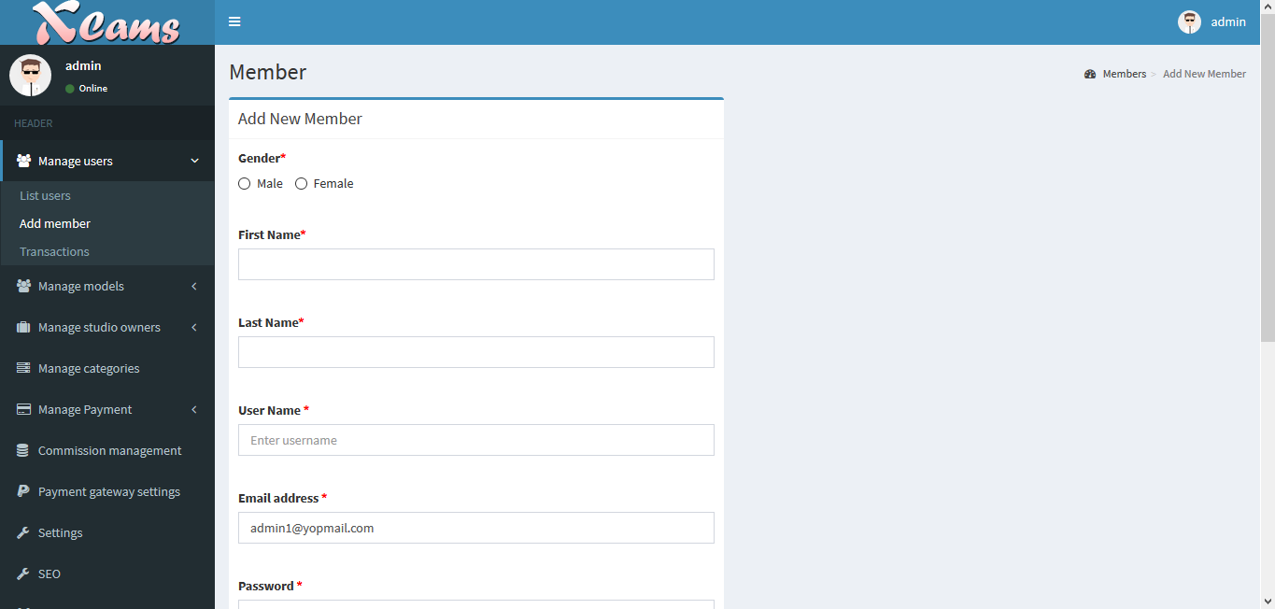

C) Transactions -

Under this option, you can check the complete list of token packages and associated details purchased by each user on the website from his account.

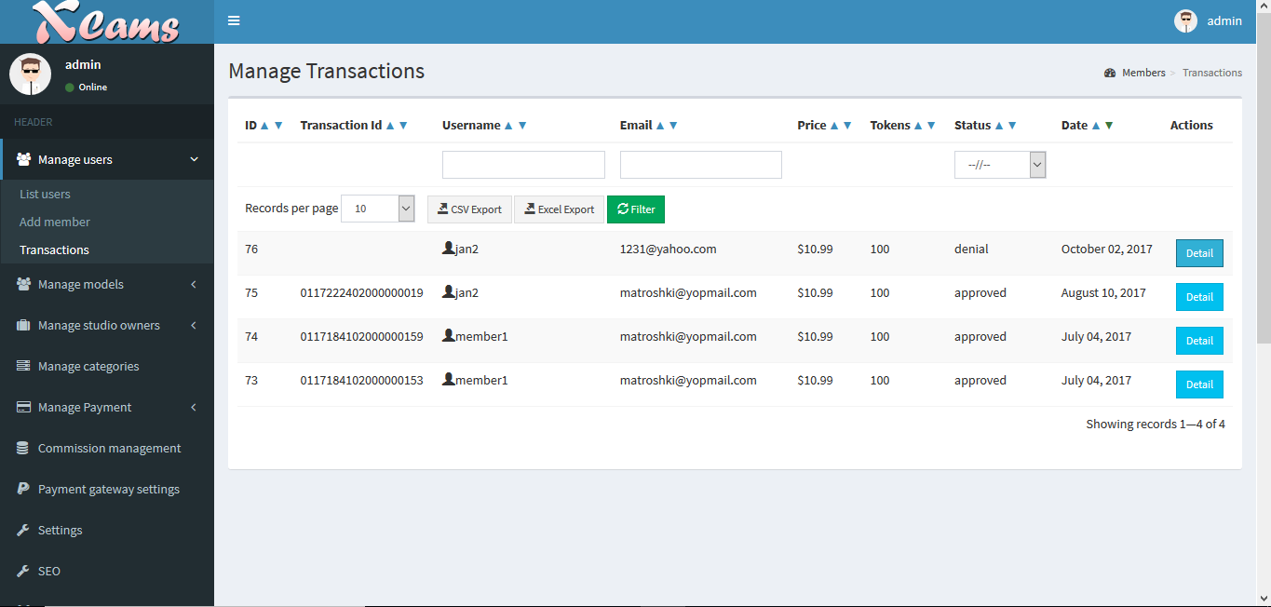

2. Manage Models

Under manage models menu, you can view/add/edit/delete any model profile on the website. It has the following options.

1. List models

Under this menu, the complete list of models is displayed who are registered on the website.

The no. of tokens a model has earned can be checked under the tokens column. This will be used by the admin for payout purpose.

Also, there are multiple icons for each model that can be selected and made changes. Some of the key ones are *picture gallery (to update a models picture gallery) , video gallery (to update a models video gallery) , Documents uploaded by a model for verification purpose and the models chat history with her client.*

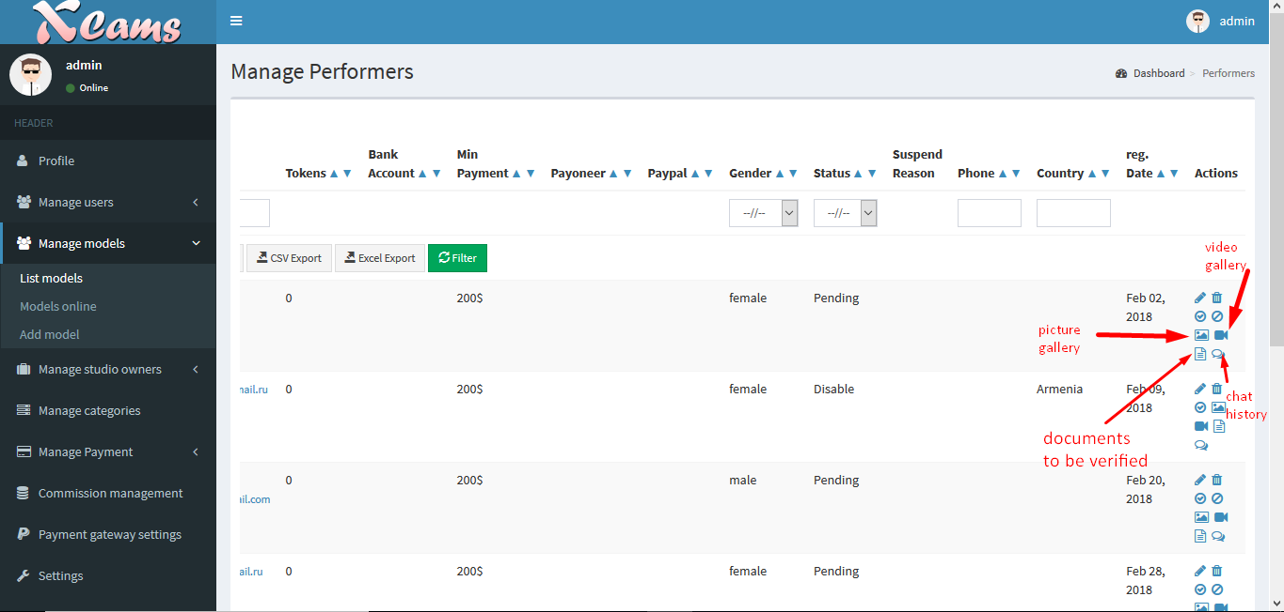

B) Models online

Under this option, you can check the statistics of a live model on the website such no. of users watching, total time model has been on live stream and what type of chat the model is on.

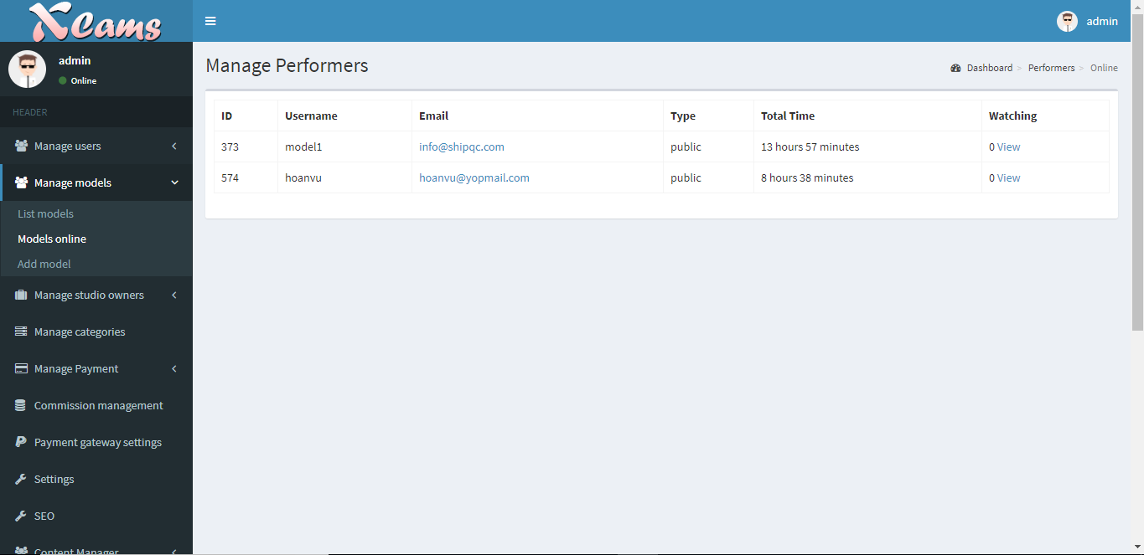

C) Add Model

Using this option, a model can be directly added from the backend by the admin.

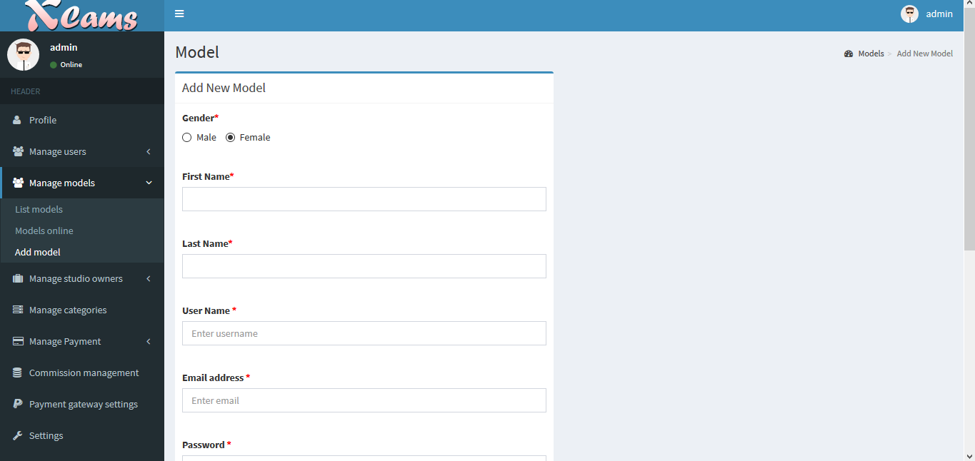

D) Manage pending models

Under this menu, you can find the list of models who have registered on the website and waiting for their accounts to be approved.

The model accounts can be approved here by the admin.

3. Manage Studio owners

This menu is for managing the studio owners who have their accounts setup on the website. A studio account must be first created from the admin panel and the account login details must be shared with studio account manager so they can login from the frontend of the website to access their dashboard which we will be seeing later.

1. List of Studio owners

Under this menu, the list of all registered studio account managers are displayed. The options and columns are very similar to the list of model menu which we saw earlier.

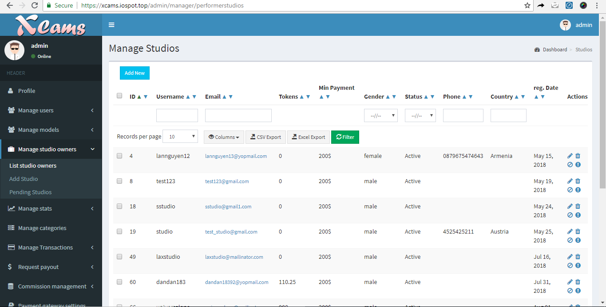

B) Add Studio

To add a new studio account on the website, it must be done using this option. You can also input all the payment details of the studio here.

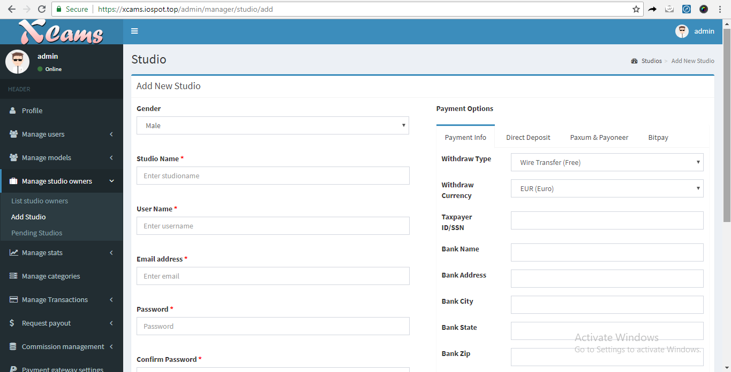

4. Manage Stats

A) Performer

Under this menu, you can see the earnings stats of each performer on the website.

-> **Total earned** : This column shows the total $$ actually earned from tippings and purchases on her profile .

-> **Tip** : Total $$ earned from tippings

-> **Private chat** : Total $$ earned from private chat

-> **Group chat** : Total $$ earned from group chat

-> **Video** : Total $$ earned from video sales

-> **Photo albums** : Total $$ earned from pictures/album purchase

-> **Physical products** : Total $$ earned from product and accessories sales.

-> **Commission %** : The % that is set by the admin for this model from the commission management menu.

-> **Earned** : Performer $$ earned after commission % calculation

-> **Admin earned** : Admin $$ earned after commission % calculation

-> **Actions** : This is an option to completely reset all calculations and earnings of a performer on the website back to ‘zero’

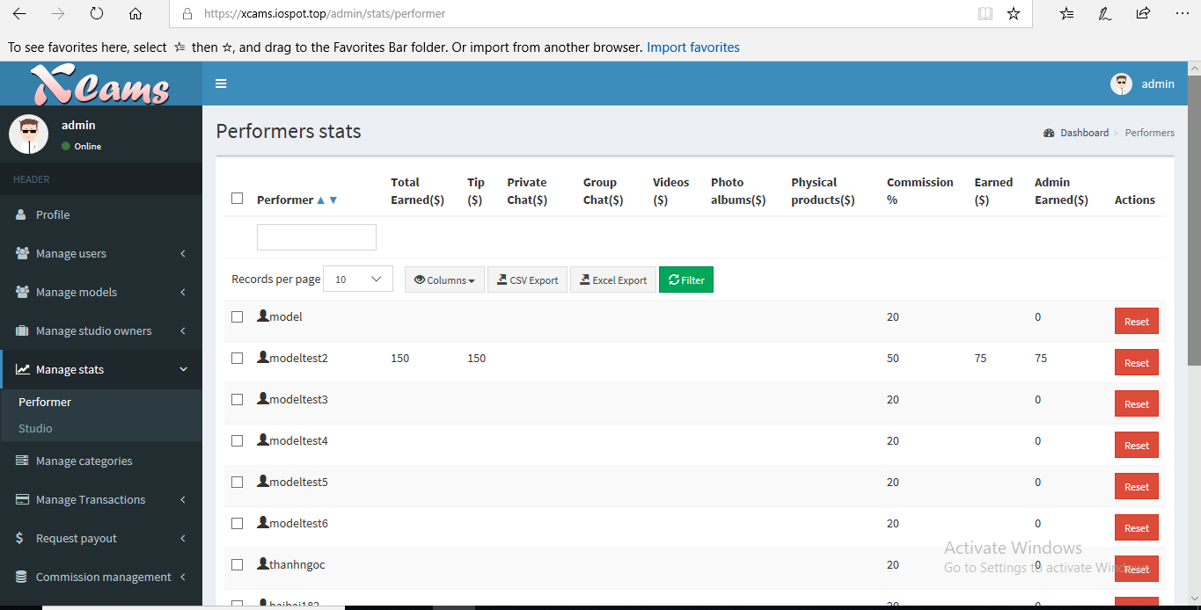

B) Studio

Under this menu, you can see the total earnings of each studio and the total no. of models under each.

Click on the Total models -> You will see the same menu as discussed earlier for individual performers earnings belonging to that studio.

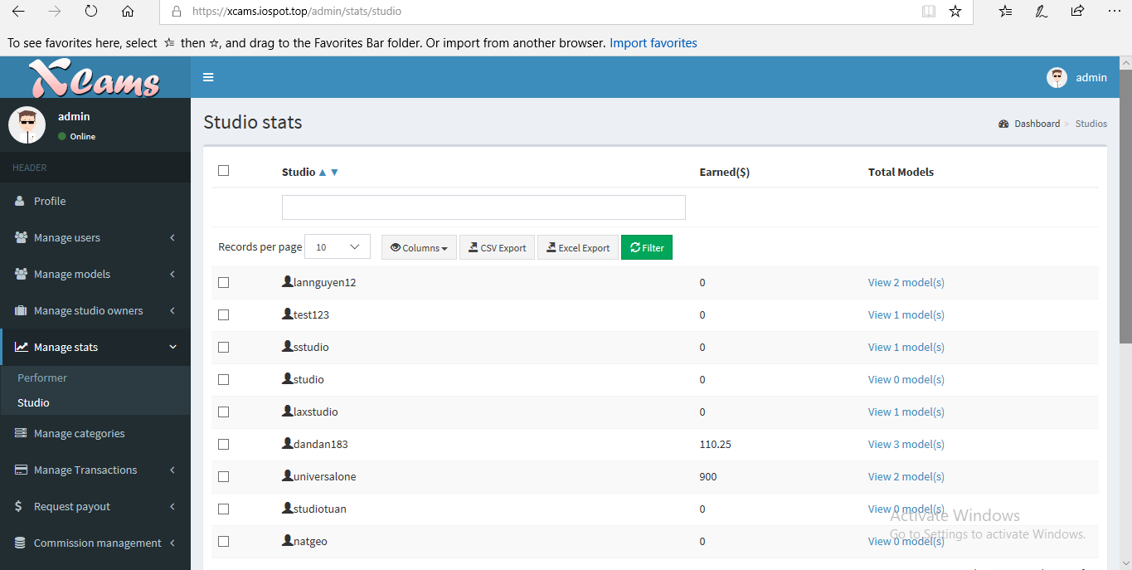

5. Categories

To add a new category onto the website for models to be categorized into, this option is used.

Categories can be added/edited/delete here.

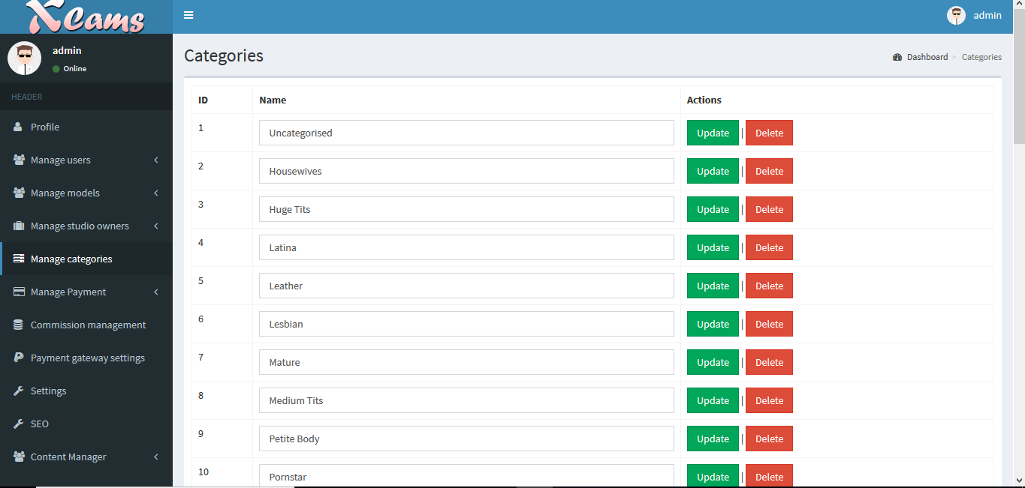

6. Manage Transactions

This is the option where all token payments happening on the website are listed with details, approved/rejected by the admin. If approved, the tokens are then sent to the respective models account as earnings. If rejected, the models will not be getting the earnings.

1. Videos -

When a user purchases a models video gallery using his tokens, the details are listed completely here. The admin can verify the token transaction and the user details and then approve or reject the same.

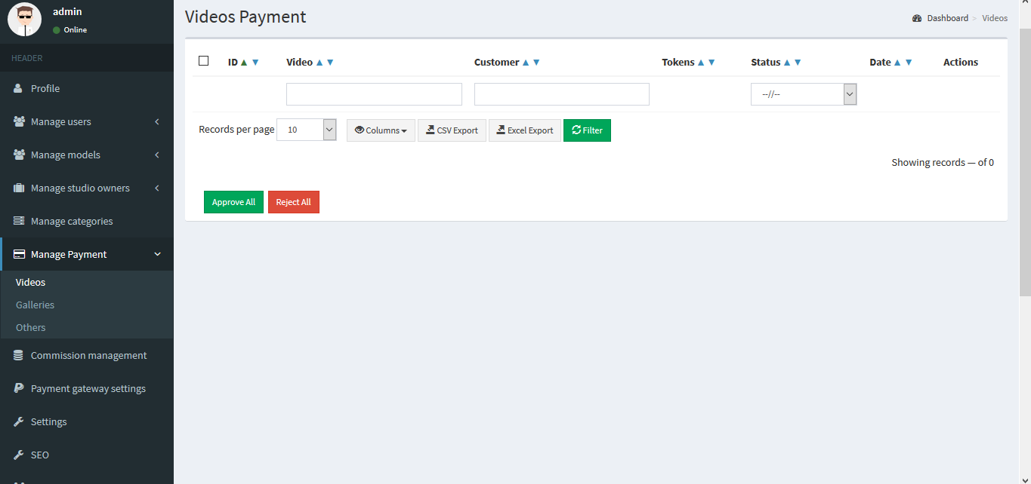

B) Galleries -

When a user purchases a models picture gallery using his tokens, the details are listed completely here. The admin can verify the token transaction and the user details and then approve or reject the same.

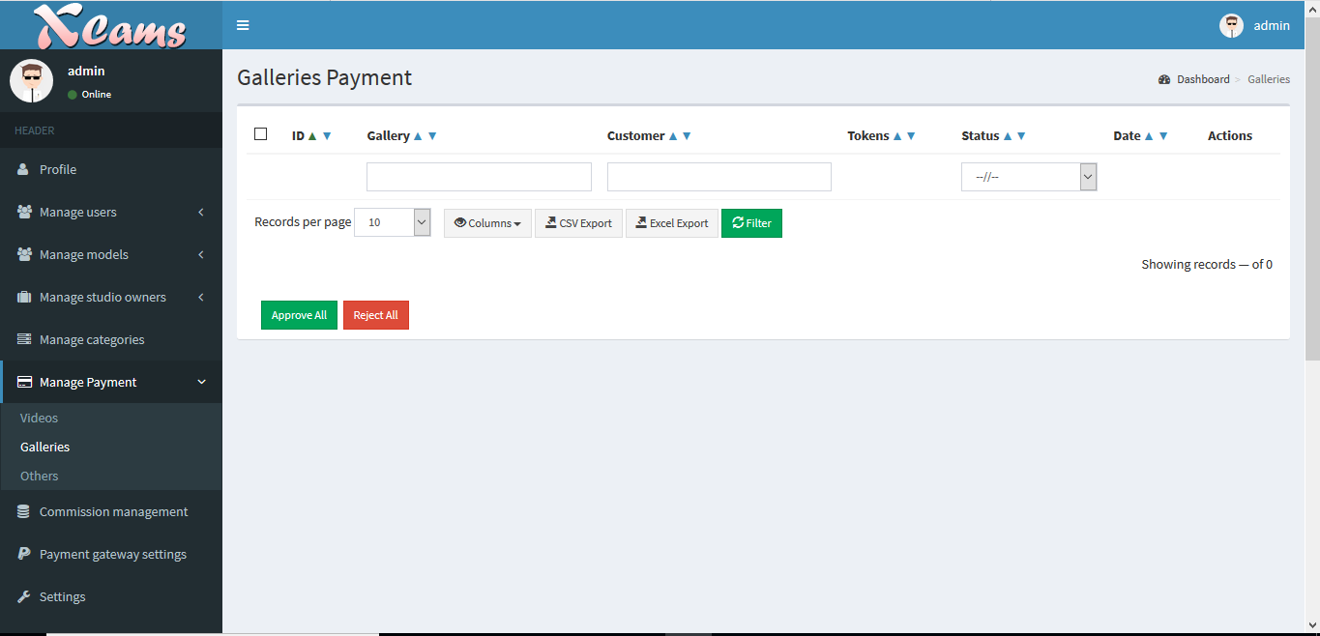

C) Tips and Private/Group

In this menu option, you can find all the tippings transaction that have taken place on the website (Free, Group and private)

D) Physical product

In this menu, you can check all the physical product purchases and transactions that has happened on the website.

The shipping status column shows the status of the purchase. When model updates the status from her dashboard, the status will reflect here.

When clicking on the actions option -> You can check complete details of that purchase and also have the option to refund the client directly.

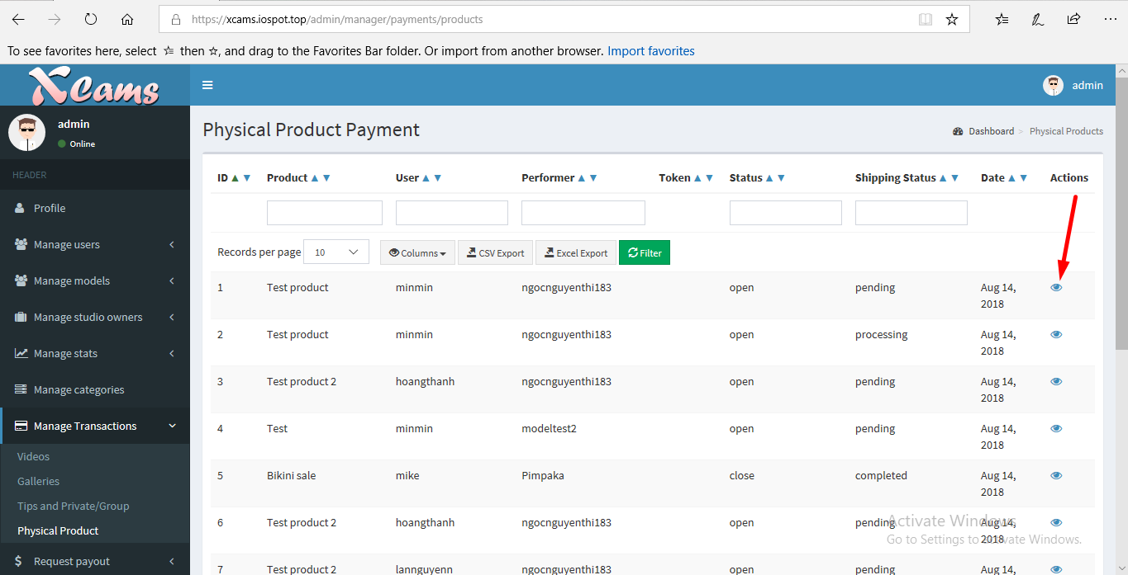

7. Request Payout :

A) List all performer requests:

In this menu, you can find all the payout requests created by the model from her dashboard.

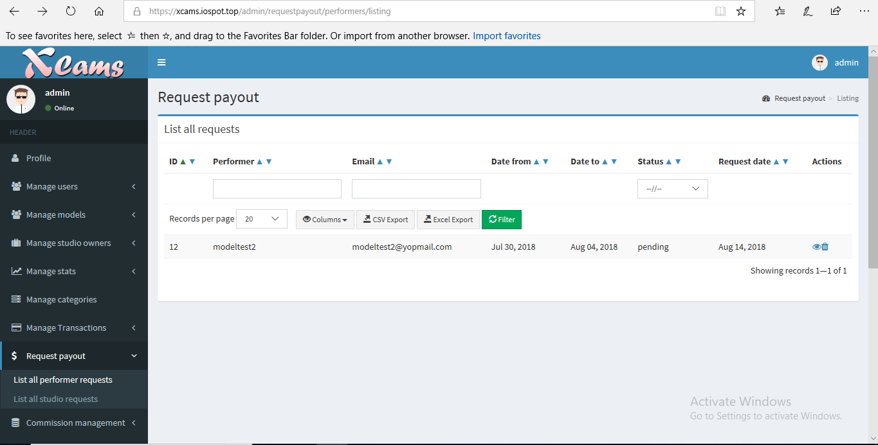

Under the actions column, click on view to check the complete payout request details. Admin has the option to add a note for his reference and also send a comment to the performer like a direct chat that they can check from their dashboard menu.

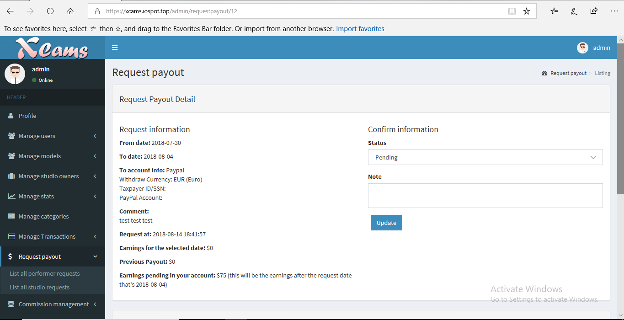

B) List all Studio requests:

Similar to the performer payout request, studios can also request payout and related details will be shown under this menu option.

8. Commission management :

Commission management is where you can set commission % earnings for each and every model and studio on your website. The tokens that a model earn from a member/user will be spilt as per the % commission set by the admin and will reflect in their earnings.

For example: If the admin sets 80% commission for a models earnings, the model will receive 80% of the tokens earned.

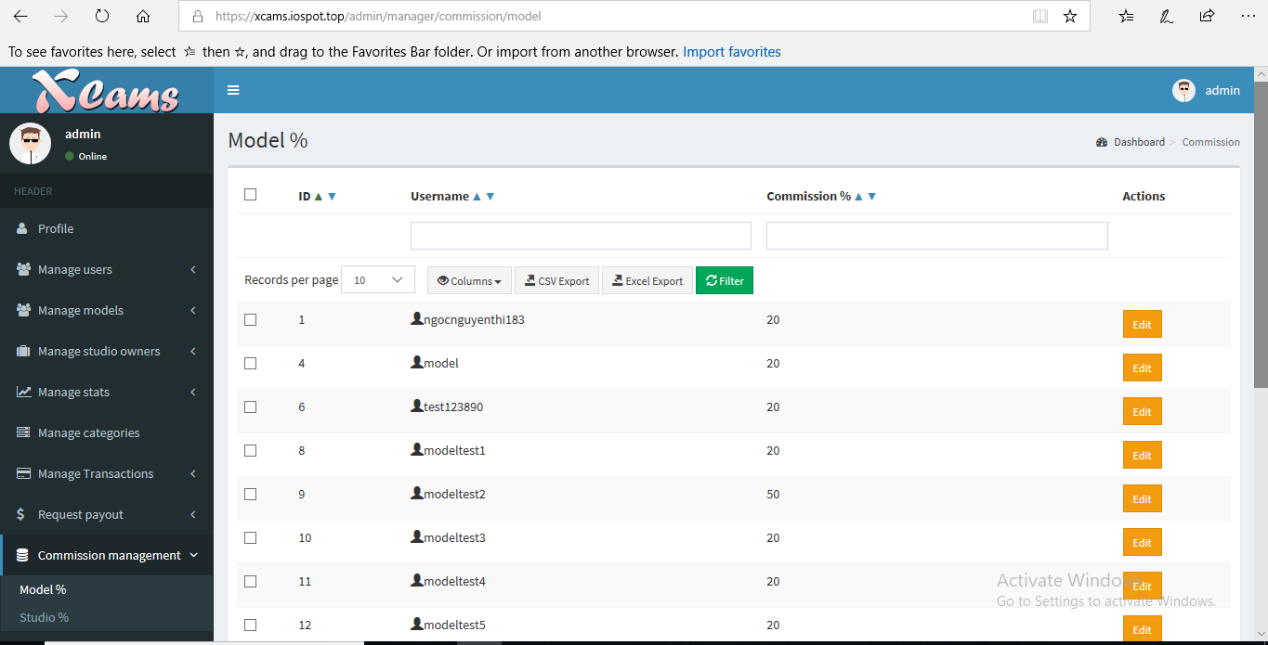

9. Payment gateway settings

1. We have integrated CCBill payment gateway with the base product. You need to create a merchant account with CCBill. Checkout the details here about creating an account <https://www.ccbill.com/online-merchants/merchant-signup.php>

Once your account has been created, you need to enter your account details in this menu to have your account configured on the website to receive payments from users who purchase token packages.

Note : CCBill is NOT our company. We are only associated with them by using their API to integrate their payment gateway. Any charges levied by CCBill to your application approval - deal with them directly. Usually all adult websites are categorized under HIGH RISK BUSINESS - which makes the payment companies like VISA and Mastercard to levy $500 deposit each.

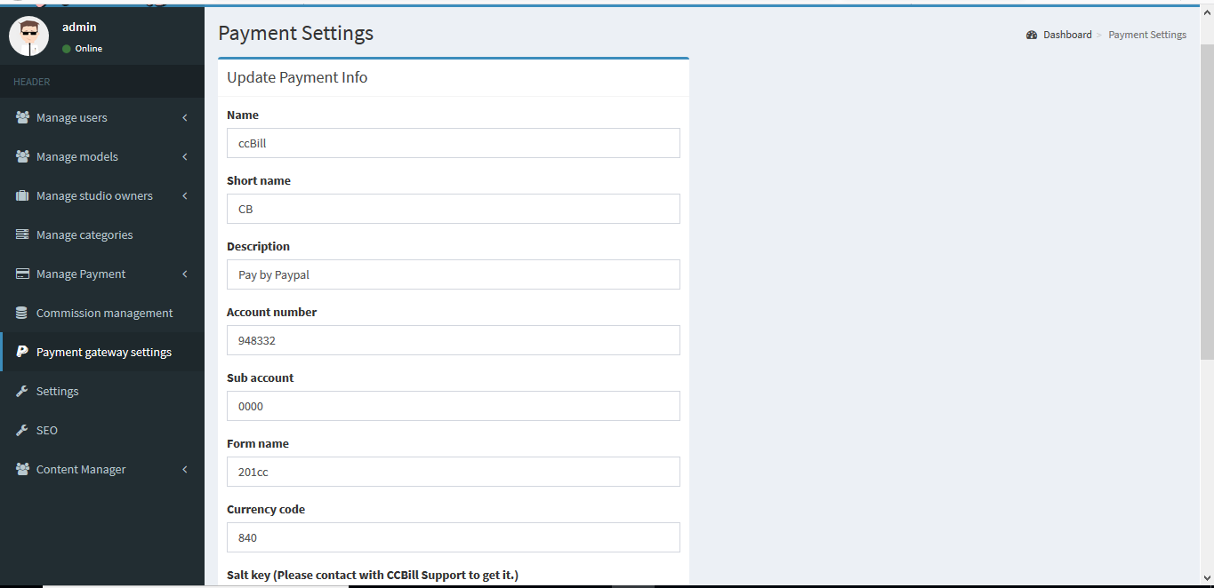

B) Token Packages Management

For users to purchase tokens and spend them on the website, the admin has to create the token packages from the packages management menu option.

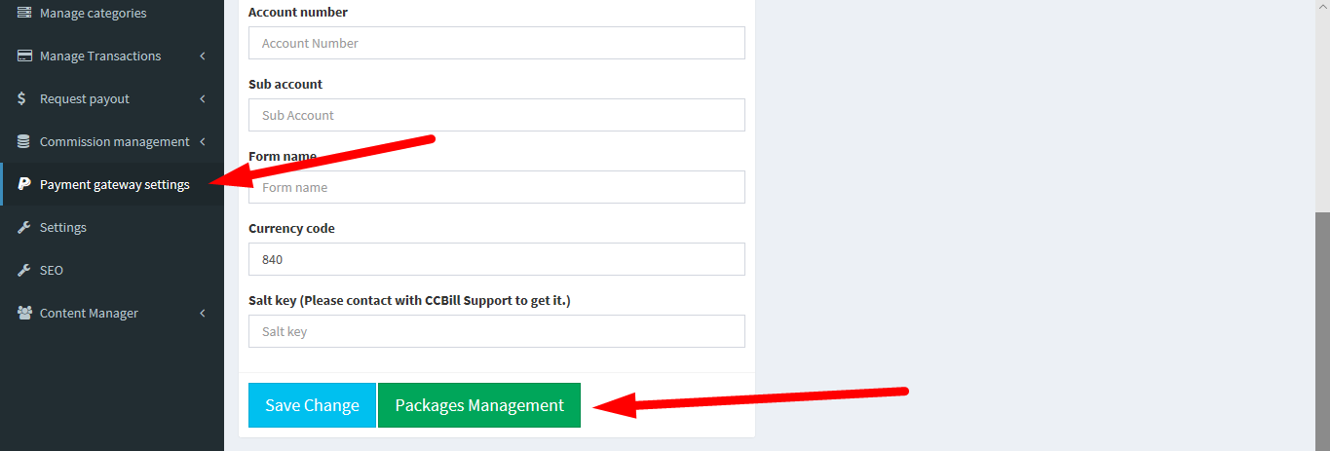

By clicking on Packages management -> Admin can create multiple token packages for users to purchase. Example -> 100 tokens for $50 with a description.

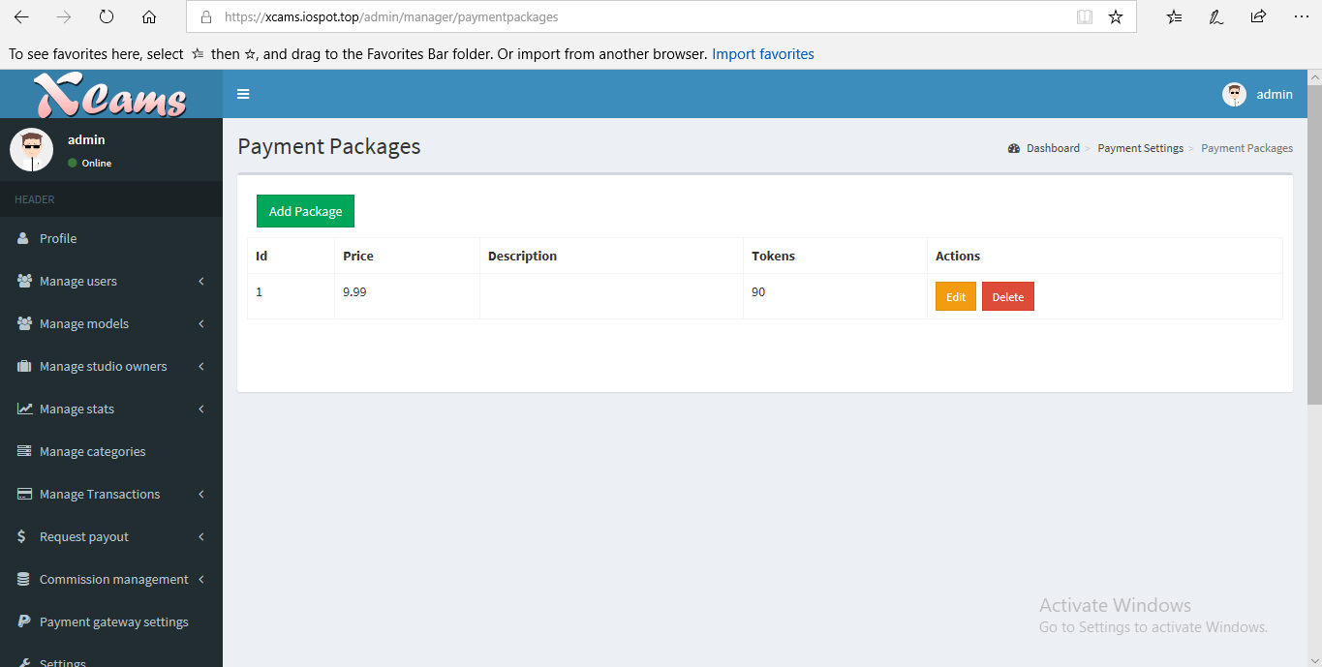

The users will purchase these token packages from their dashboard.

10. Content Manager :

1. Pages :

Multiple no. of static pages can be created/edited/deleted from this menu option. The static pages will be created and will have the links in the footer area of the website.

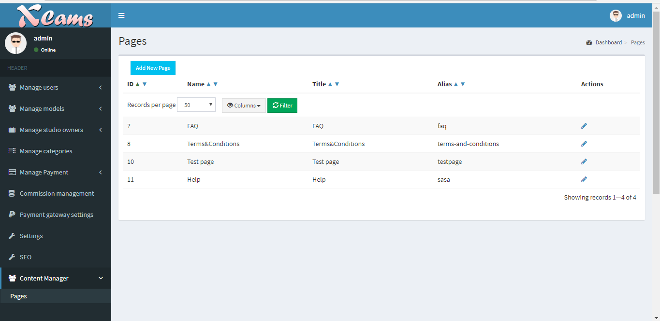

**Frontend Model Login and Dashboard :**

Model can signup and login on the home page. To login, model needs to use their username and password alone.

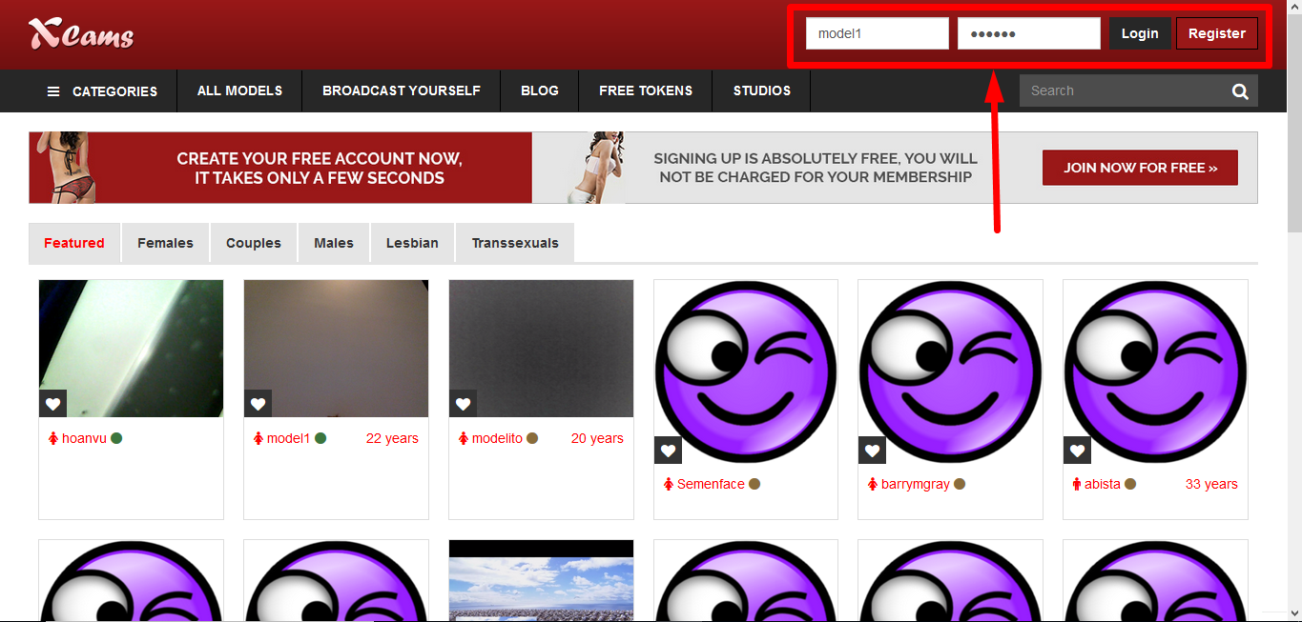

Once logged in, the model will enter their streaming window with public chat. They can directly start streaming from there or start a group chat as well. The model can access their profile dashboard from the same page as well.

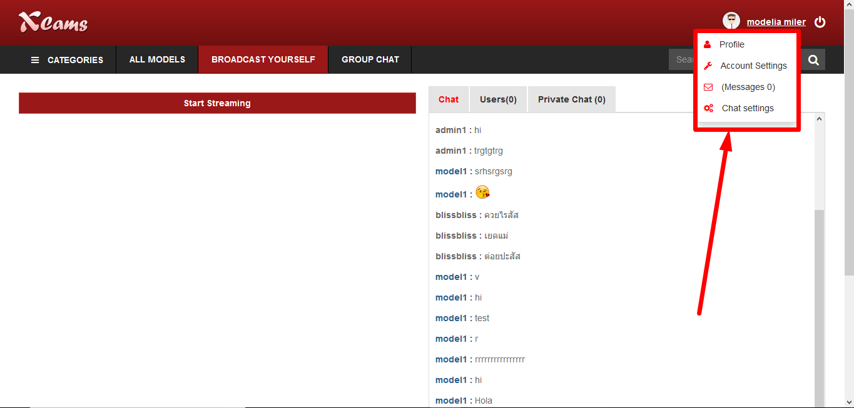

Model Dashboard :

1. Edit Profile:

When model enters their profile dashboard, they can edit their profile with personal details and also input their personal blog details that will be shown in the blog section on the navigation bar of the home page.

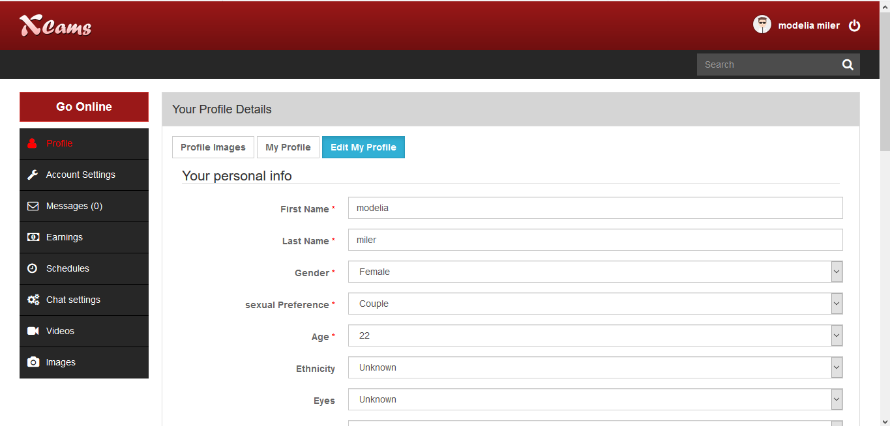

B) Account Settings :

-> Commissions :

The commission % that the admin sets for the model in the commission management menu on the admin panel will be shown here for the model to refer.

-> Documents :

When a model creates his/her account, they will be asked to upload their identification documents here for the admin to verify from the admin panel .

-> Time Zone :

Models can update their timezone for their users to know their stream schedule.

-> Contact settings :

Models contact details can be updated from this menu for the admin.

-> Payment Info

For payout purpose, models can update their wire transfer, Paypal and Cheque details from this menu. Admin can check the details when he gets a payout request from the model.

-> Direct deposit

If model wants a direct deposit of the payout money, then the details can be entered here.

-> Paxum , Payoneer, Bitpay

For these payment options, details can be entered here.

-> Change password :

The model can change their account password using this option.

-> Disable account :

If the model wants to suspend their account, it can be done using this menu giving a reason too for their voluntary suspension.

C) Messages :

The models can check their personal messages that have been sent from their members here.

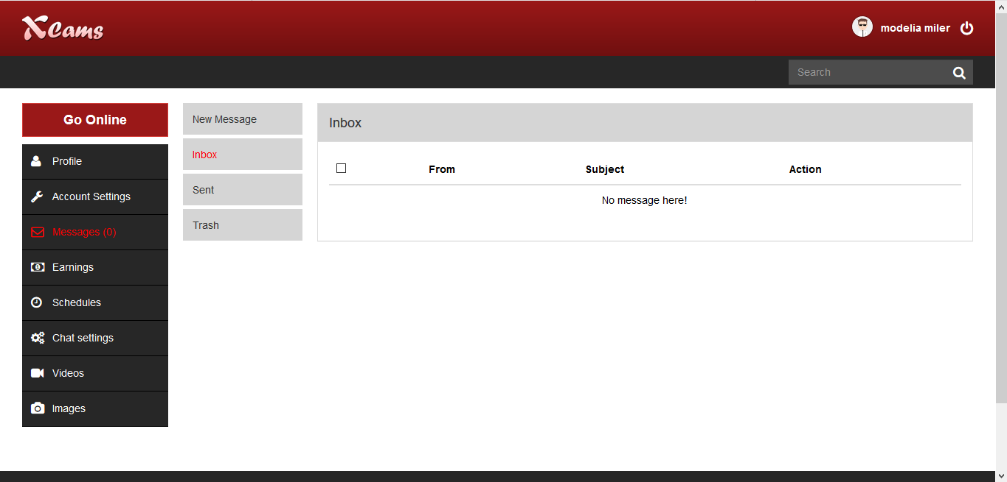

D) Earnings :

Under this menu, the model can check their complete history of earnings with every details such as who paid, date, time, chat type and no. of tokens.

They also have the option to download the complete earnings data.

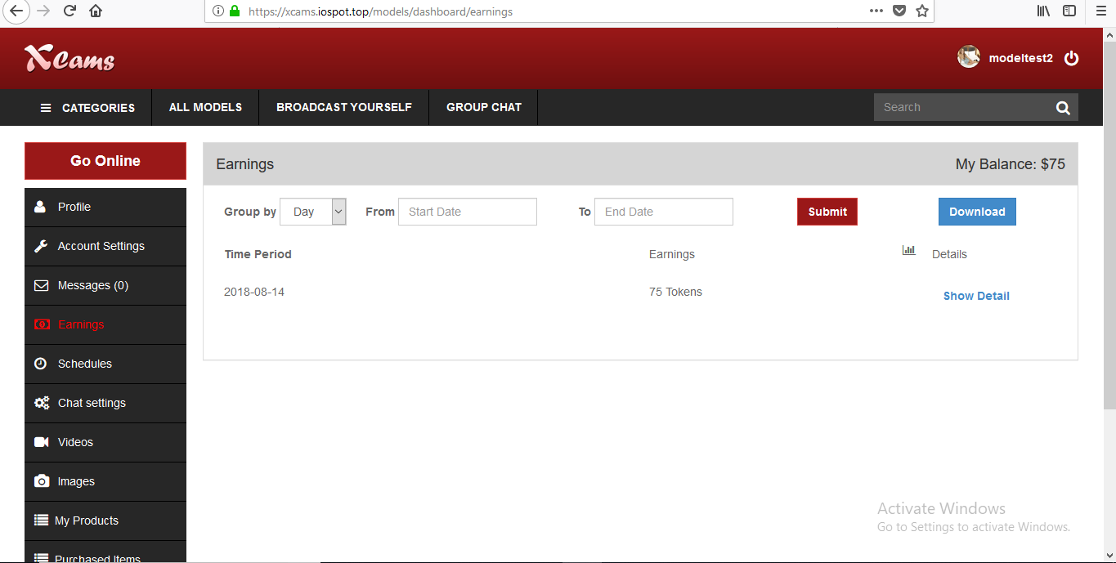

E) Schedules :

Models can update their schedule time and date of cam show along with their timezone from this option that will be displayed on the models profile page for a member when they enter.

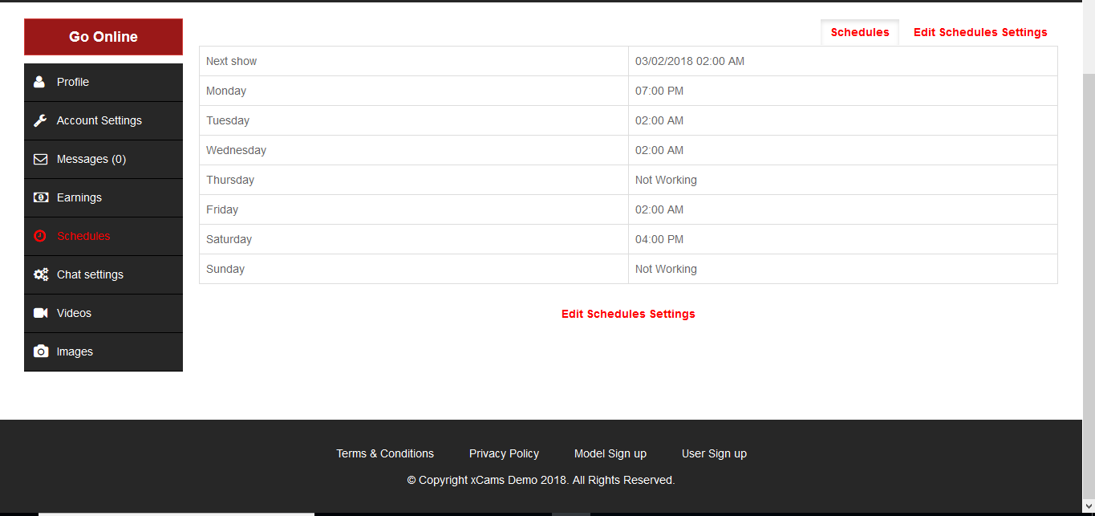

F) Chat Settings :

The model can change the default price of their private/group chat that is set by the admin from the backend.

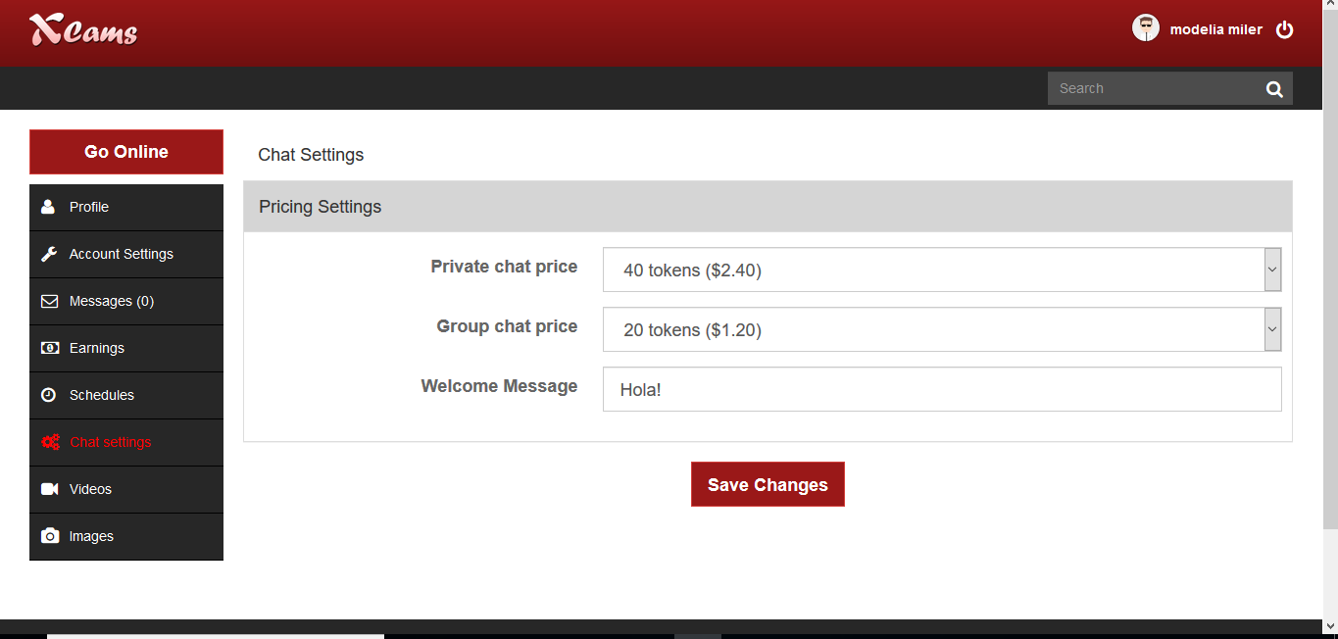

G) Videos :

The models can sell videos on their profile to the members for a certain token price. They can create their own galleries and upload videos and fix a price for each video.

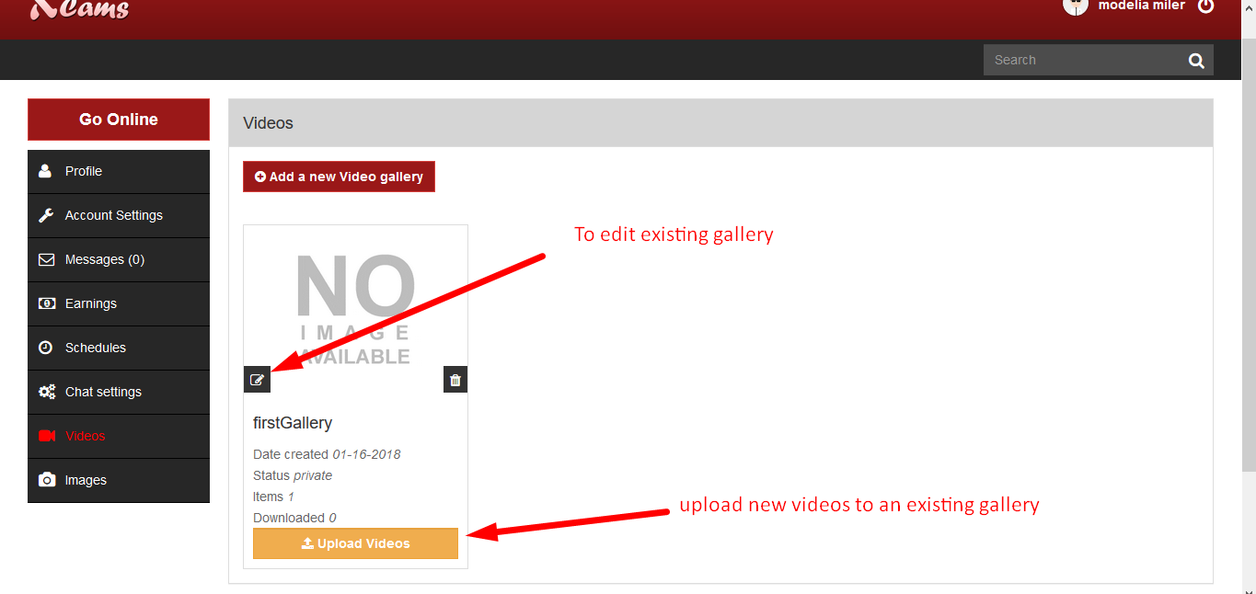When uploading videos, models give the title , description and set the unit price for that video.

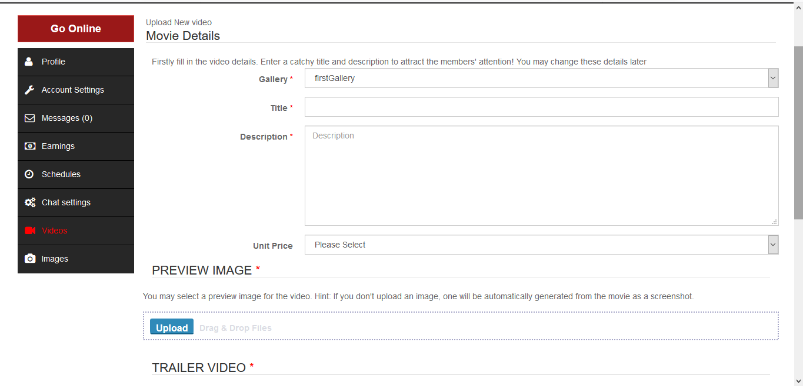

The models have the option to upload preview image and trailer video for the full length video that they want to sell.

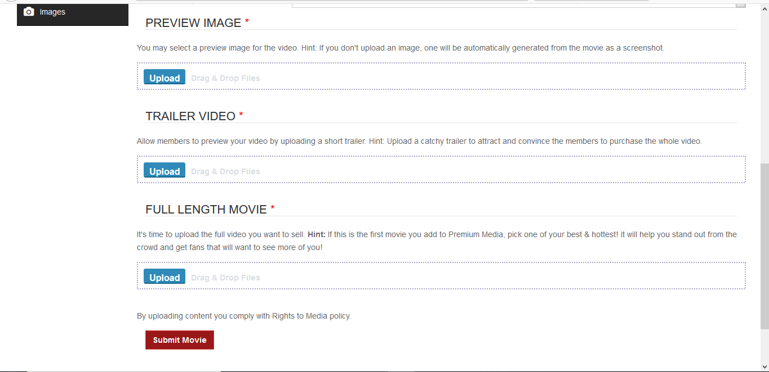

H) Images :

Models can also sell the pictures as a whole gallery for a fixed price from this menu.

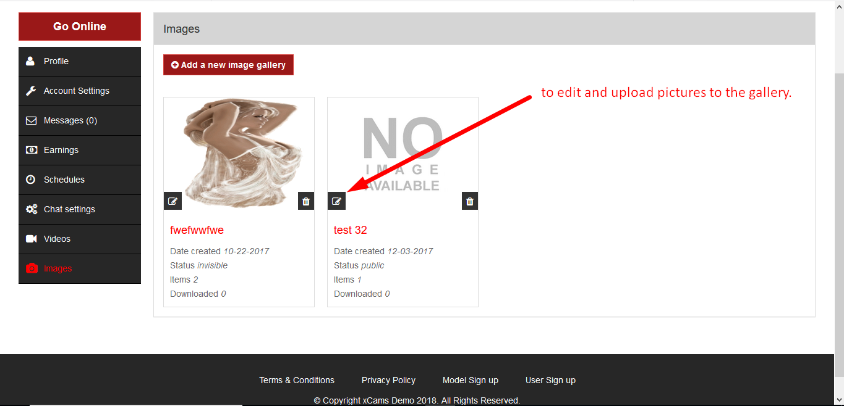

The gallery details can be updated with name and description. Also, the price ans status of the gallery can be fixed from here.

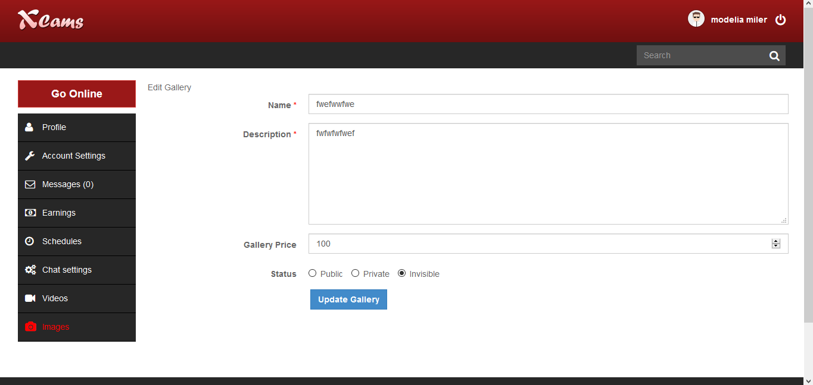

I) My Products :

Performers can also sell their own products/accessories on their profile using this menu option. Details such as name, no. of tokens , stock count, description and image can be updated.

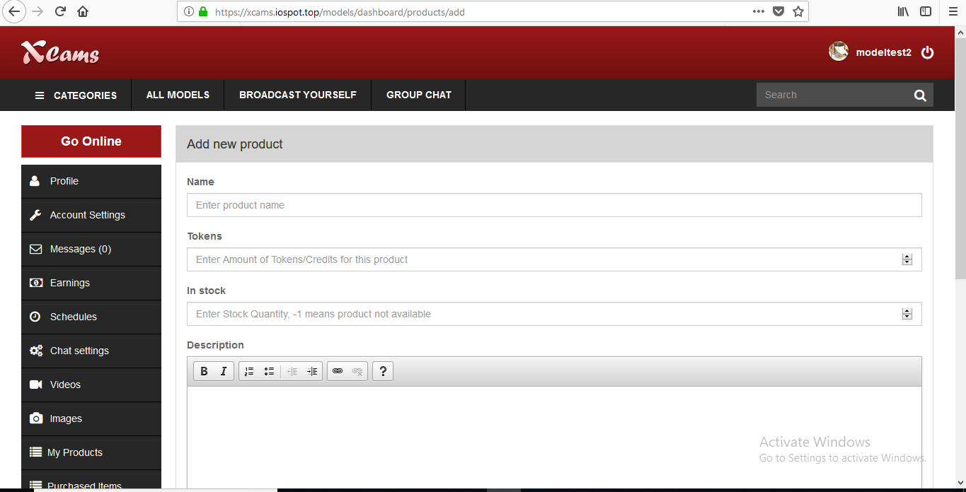

J) Purchased Items :

Under this menu, the performer can check the list of products that have been purchased by users and all related details.

<http://prntscr.com/kimzsg> -> By clicking on the view details button, the performer can check in depth details about the purchase and also edit the status of it.

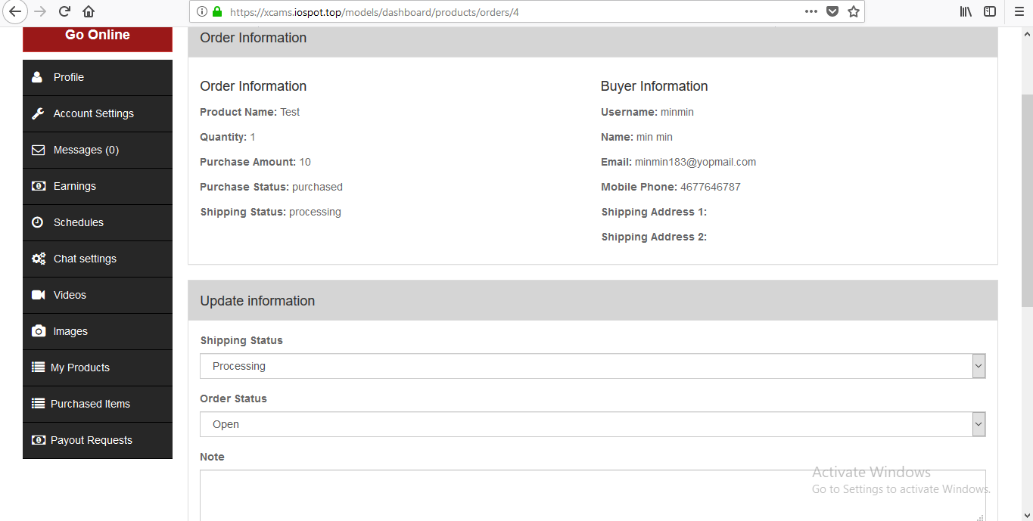

K) Payout requests :

Performers can request for their earnings payout to the admin from this menu option. Performer can view the list of payout requests done so far and its details and also edit any requests done.

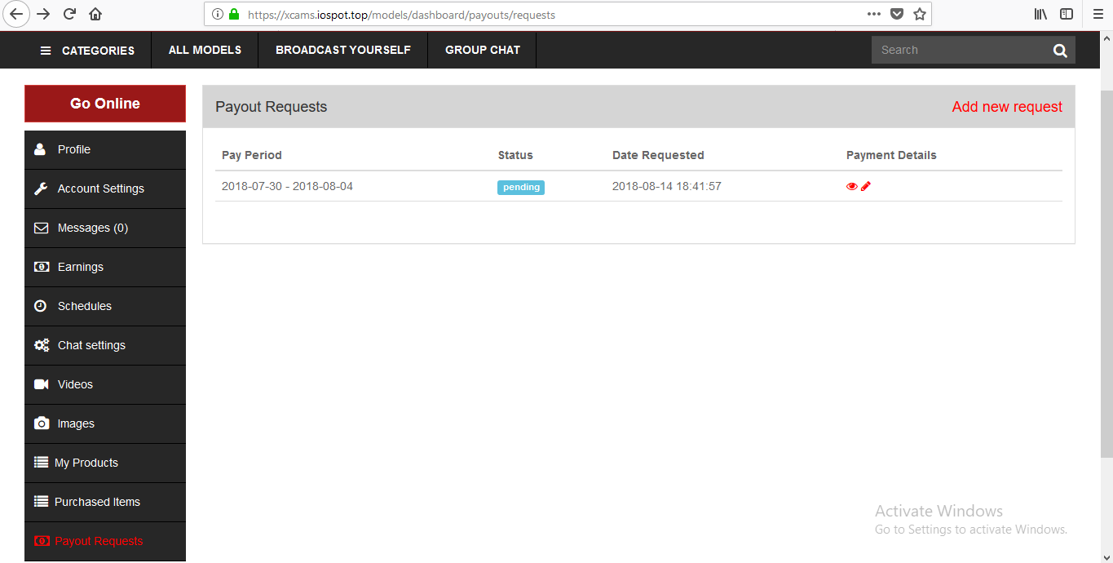

**Frontend User Login and Dashboard :**

User can signup and login on the home page. To login, user needs to use their username and password.

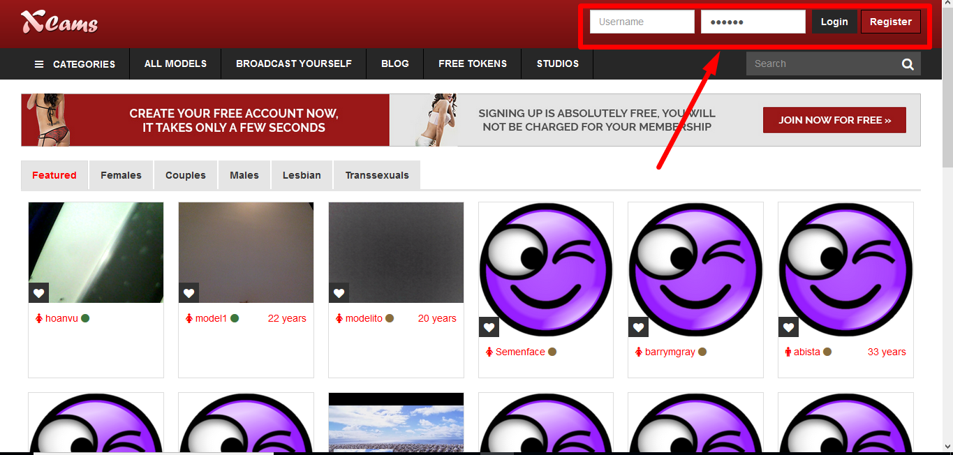

1. Account settings :

Users basic account/profile details, time zone and password can be updated using this menu.

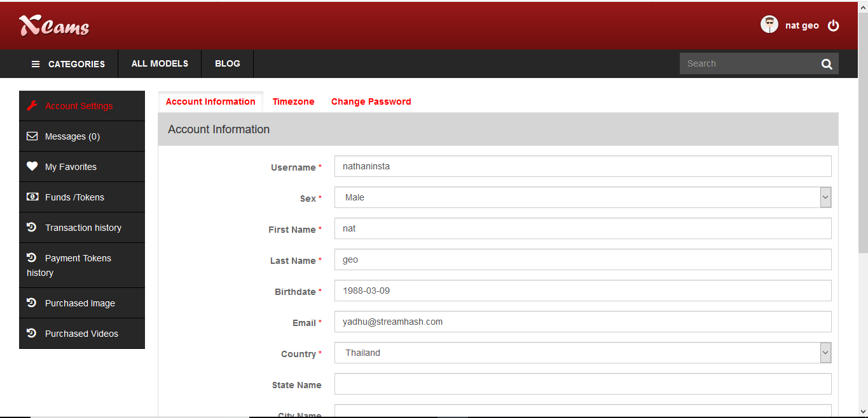

B) Messages :

The users can check/send/receive personal messages from models.

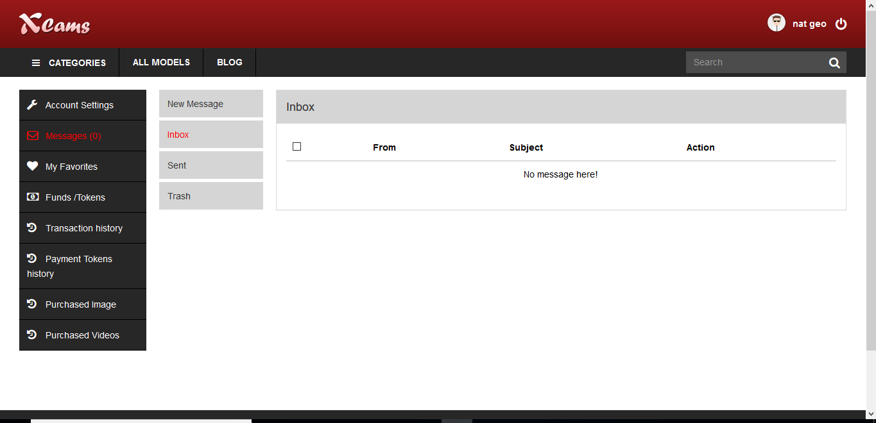

C) My Favorites :

Models favorited by the member will be listed here .

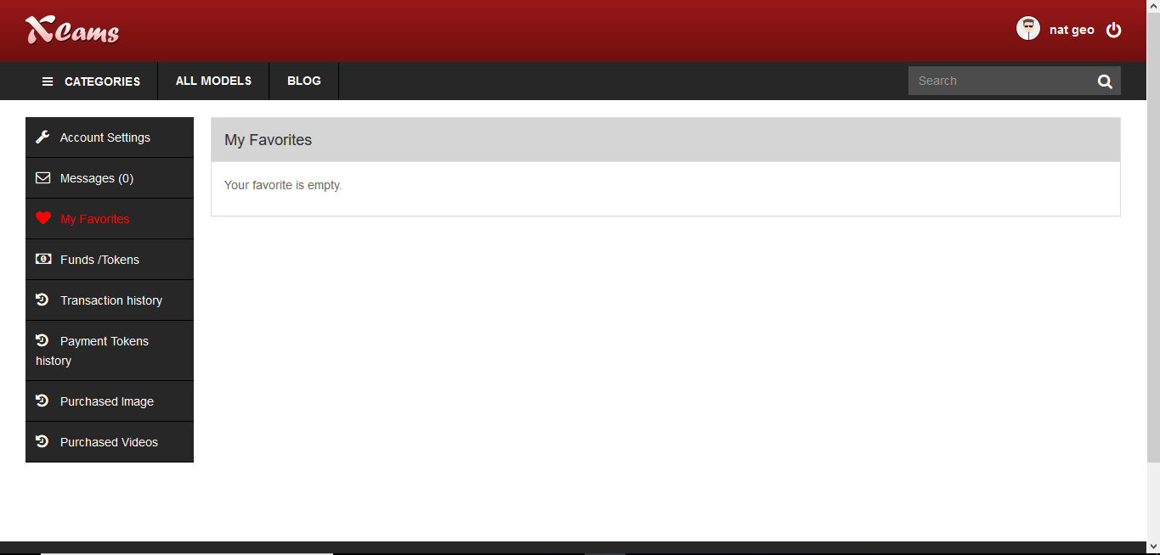

D) Funds/Tokens :

The member can check the no. of tokens they have in this menu. Also, this is where the member needs to purchase token packages.

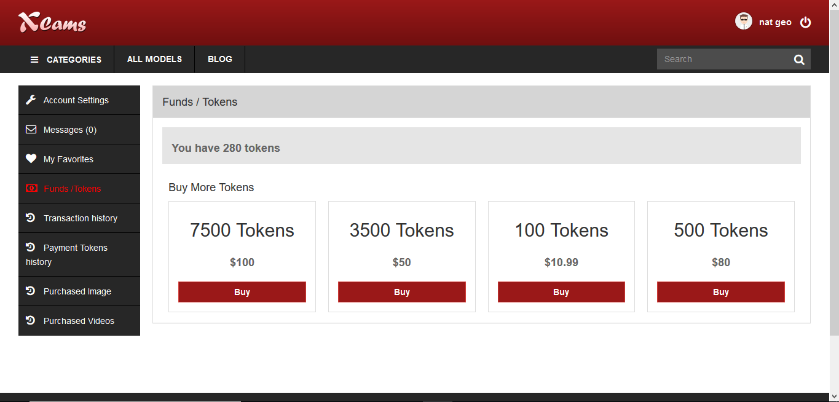

E) Transaction History :

Members can check their token packages purchase transaction history in this menu with all details.

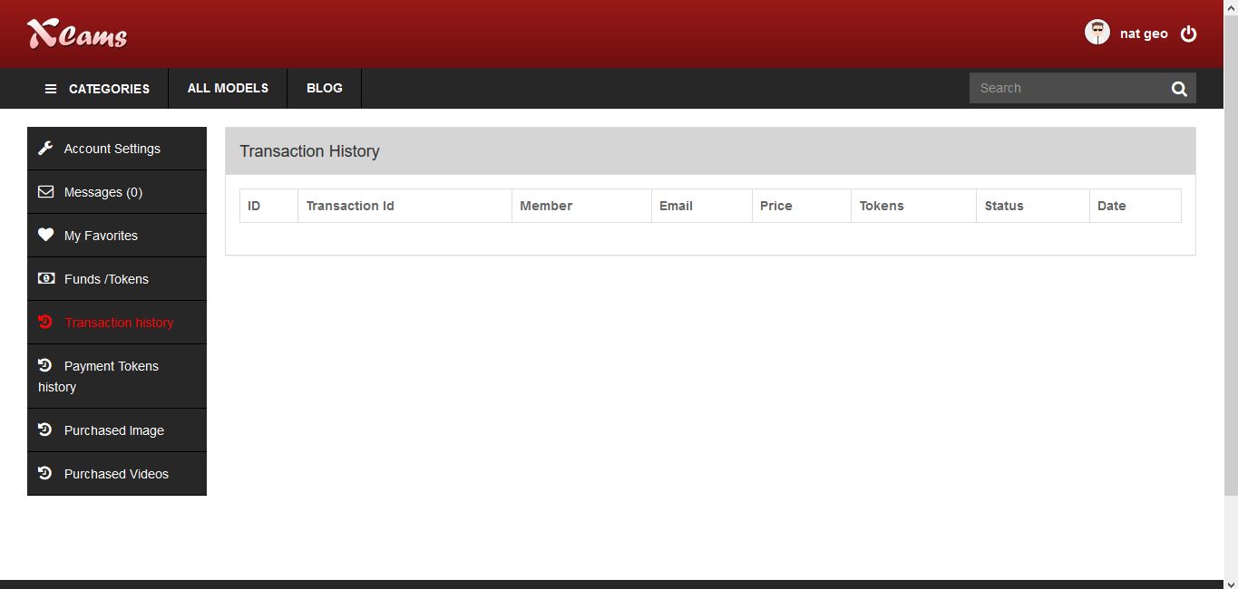

F) Payment Tokens history :

Under this menu, the member can check the complete list of tokens they have spent on the website with all details such as date/chat type or item/no. Of tokens .

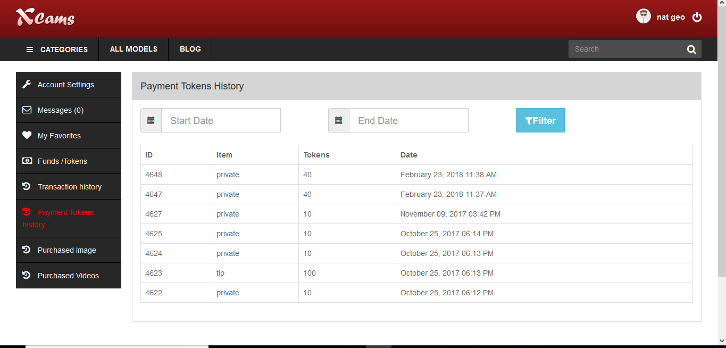

G) Purchased Image and videos:

Images and videos purchased from a models profile will be shown here for the member to view the same.

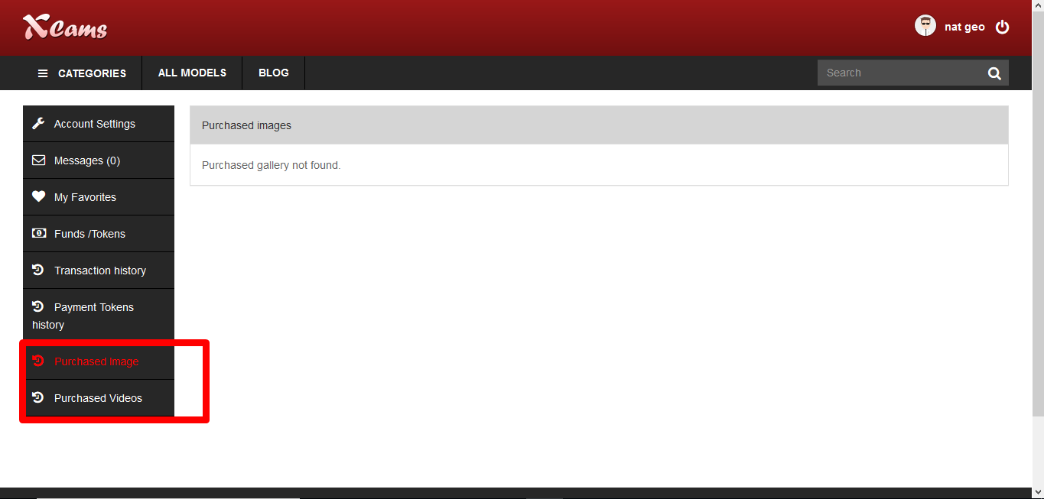

H) Purchased Products:

In this menu, users can check the list of transactions they have made to purchase physical products and accessories from a models profile. They can check the shipping status, token value for the product spent, order date and status and quantity.

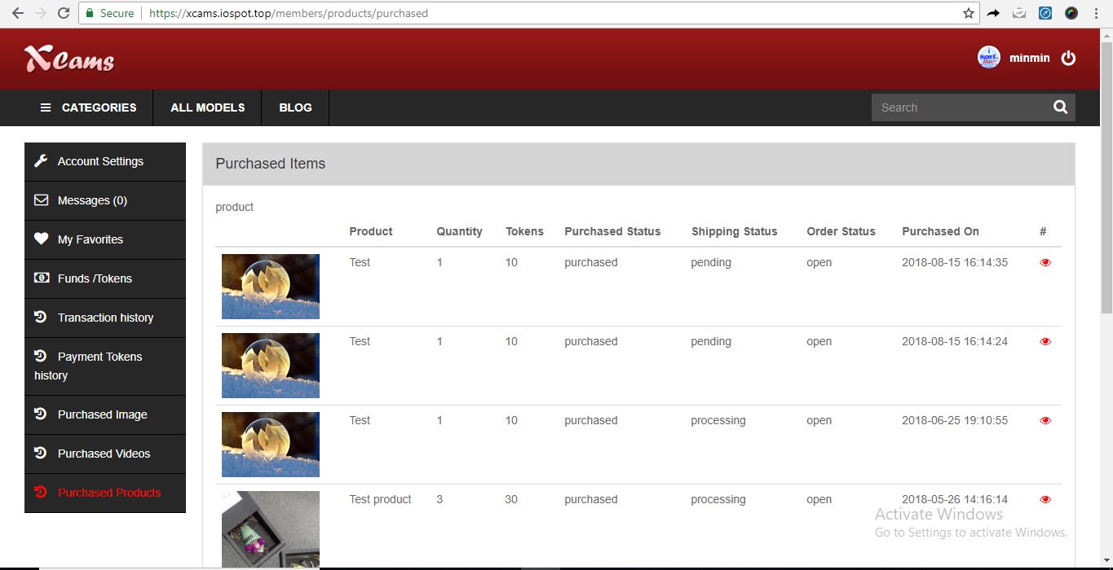

By clicking on the view button, users can check further details about the product purchase and the status updated by model from her side. Any notes or comments left by model can also be checked and replied back from this option by the user.

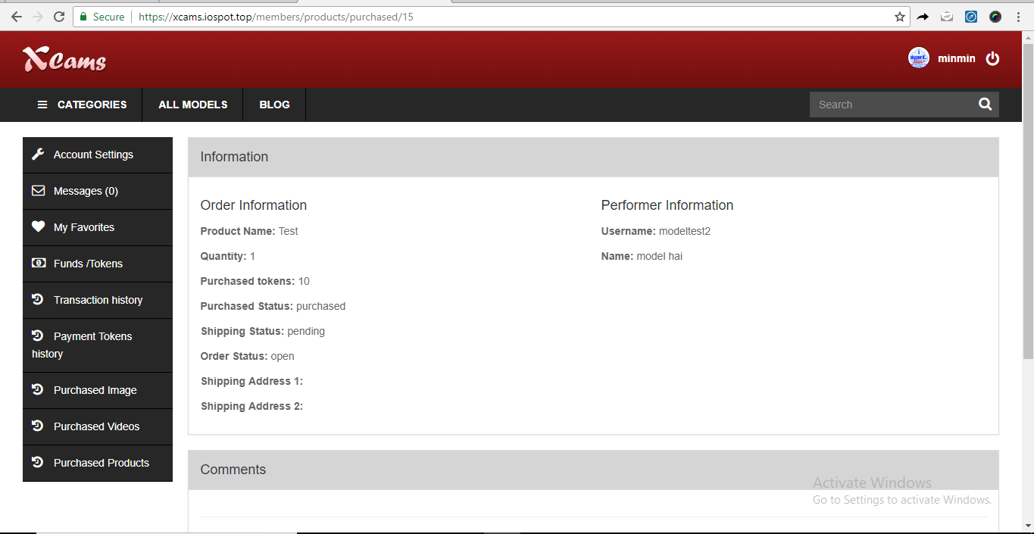

**Frontend Studio Login and Dashboard :**

Studio owners can login from the frontend by click on the studios menu on the navigation bar.

They need to enter their username and password to login to their dashboard.

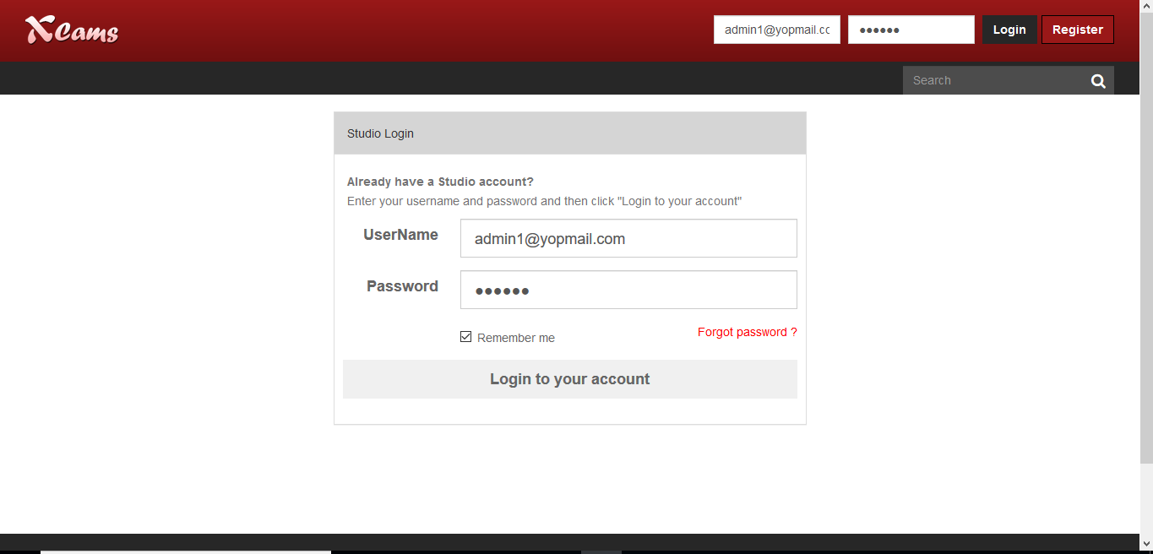

1. Account settings :

Under account settings , studio manages can update their profile and also their payout details for the admin to verify.

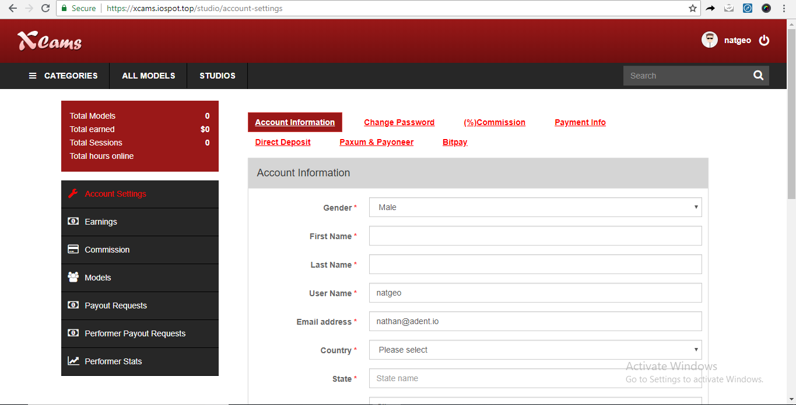

B) Earnings :

Studio owners can check the complete history of earnings with every details such as who paid, date, time, chat type and no. of tokens.

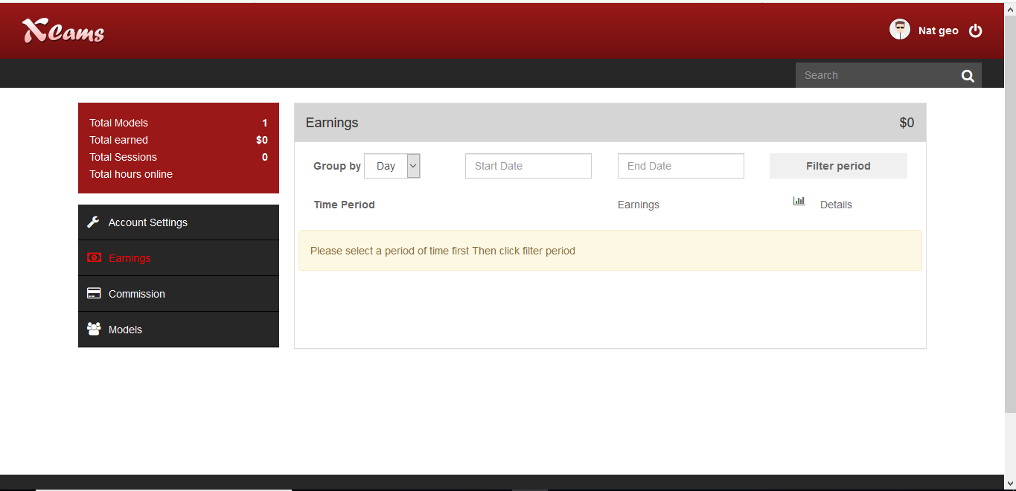

C) Commission :

In this menu, studio owners can check the commission % allotted by the admin for their models and also edit and update the same.

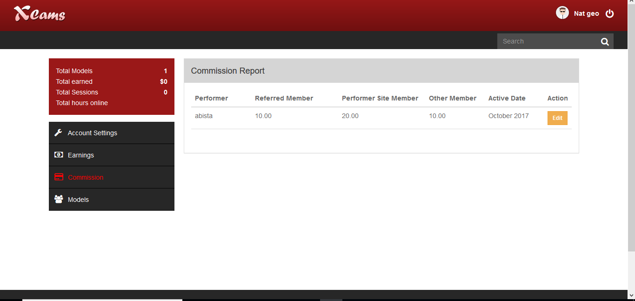.

D) Models :

The studio owner can add a new model and view the list of models working for the studio in this menu option. Existing model profiles can also be edited/deleted. Specific model details such as no. of hours the model has spent online on stream and also the models earnings can also be verified from this menu.

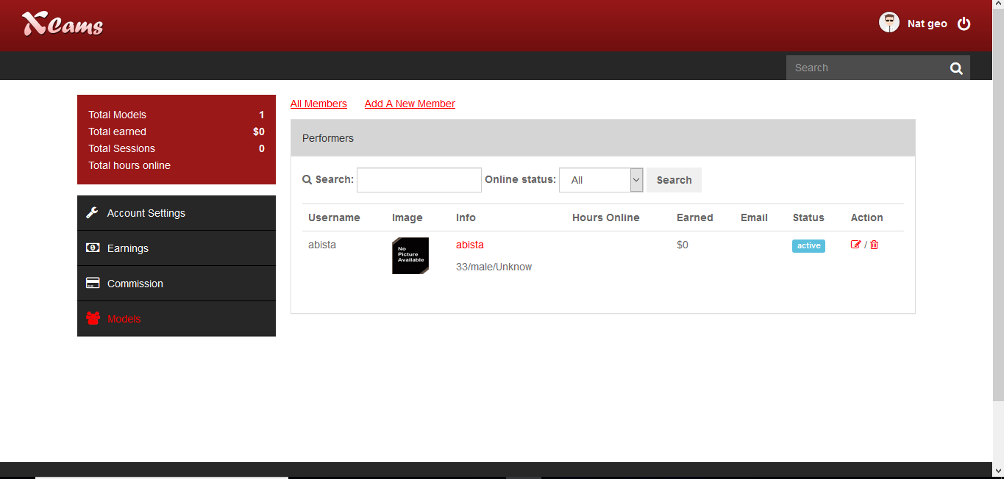

E) Payout requests:

From this menu option, studio manager can request payout to admin.

Options like filter period, status, view request details and add new request are available.

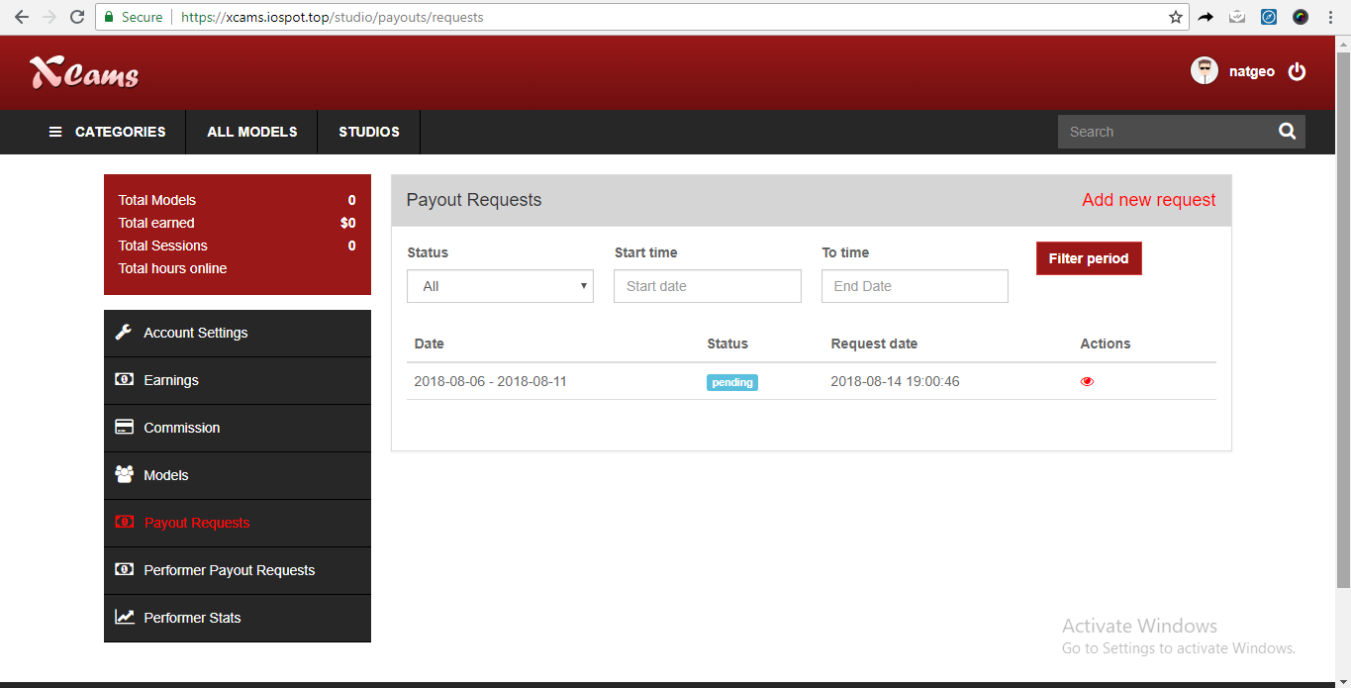

F) Performer Payout requests:

Models working under the studio when giving payout requests will be shown under this menu option. All the related details will be shown here.

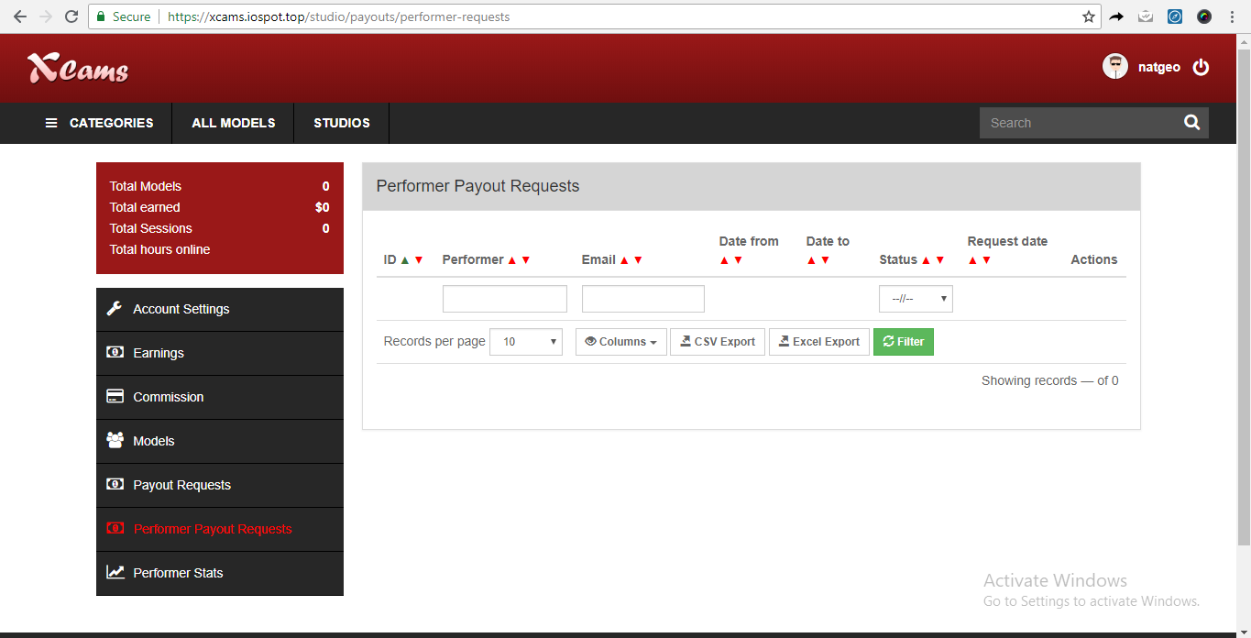

G) Performer Stats:

Performers working under the studio, all their related stats similar to admin panel performer stats will be shown here.

